
FURTHER MATHEMATICS
TRIAL EXAMINATION 2
2002
SOLUTIONS

_____________________________________________________________________

Section A – Core - solutions

Question 1

- For the box plot, use your calculator to obtain the 1-Var stats.
Namely:
Plot these on the box plot as shown on the diagram below.

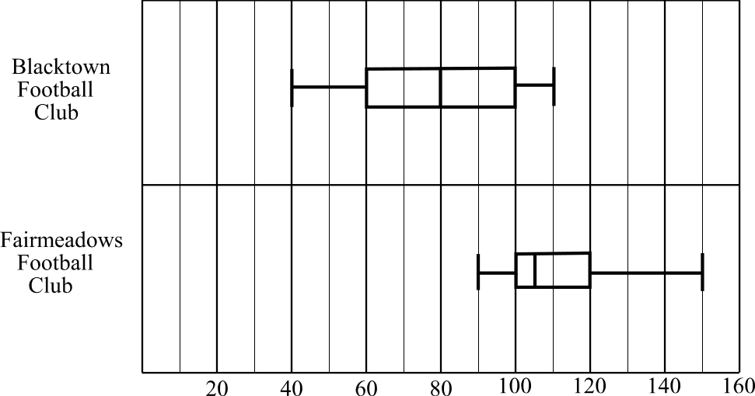

(1 mark) for the box
(1 mark) for the whiskers

- Shape – The distribution of the Blacktown F. C. canteen is reasonably symmetrical whereas the distribution of the Fairmeadows F. C. canteen is positively skewed
(1 mark)
Centre – The median number of hotdogs sold at the Fairmeadows F. C. canteen is higher than the median number sold at the Blacktown F. C. canteen. (1 mark)

Spread – The distribution for the Blacktown F. C. has a slightly larger spread than the distribution for the Fairmeadows F. C. canteen. (1 mark)

Question 2

- There were 59 people in this category who bought confectionery.
(1mark)

- Now 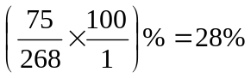 (to nearest whole percent).
So 28% of people 18 and over who bought one item at the canteen bought a hot drink. (1 mark)
Because we are calculating row percentages we divide by the row total.

- People aged 18 and over showed a clear preference for hot food (53%) and hot drinks (28%). Cold drinks (9%) and confectionery (10%) were not so popular.
(1 mark)
People under 18 years of age preferred cold drinks (38%) with hot food (27%) and confectionery (26%) almost equally popular and hot drinks (9%) not terribly popular.
(1 mark)

Question 3

- The dependent variable would be the number of hotdogs sold since it would be reasonable to expect that on colder days you would sell more hotdogs and vice versa; that is, the temperature dictates people’s eating habits.
(1 mark)

- We assume that the relationship is linear.
(1 mark)

- Enter the data from Table 4 into your graphics calculator and find the equation of the least squares regression line.
(2 marks)

- i. Again, from your calculator, read off Pearson's product moment
coefficient.
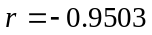
(1 mark)

ii. Now, 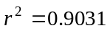, so 90.31% of the variation in the number of hotdogs sold can be explained by the variation in the maximum temperature of the day.
(1 mark)
Total 15 marks

Module 1: Number patterns and applications

Question 1
- In 2001, 240 cases of wine were exported. In 2002, 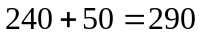cases of wine are to be exported. (1 mark)
- Method 1
Continuing on from part a., we have in 2003 that there are to be 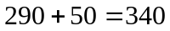cases exported.
In 2004 there are to be 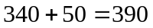cases exported.
In 2005 there are to be 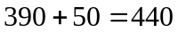cases exported. (1 mark)

Method 2
We have an arithmetic sequence with a = 240 and d = 50.
So, given 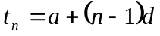
We have 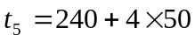
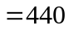
So 440 cases are to be exported in 2005. (1 mark)
- Method 1
Using a calculator,continue on the process begun in part b. Method 1, that is, keep adding 50 to the previous sum. The sequence generated is
240, 290, 340, 390, 440, 490, 540, 590, 640, 690, 740,790
The 12th term is the first to exceed 750. Since the 240 term corresponds to the year 2001, the 12th term corresponds to the year 2012. (1 mark)

Method 2
Using the formula generated in part b. Method 2, we have 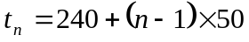.
We require the smallest value of n such that
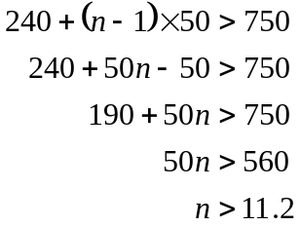
So the next whole value of n is 12.
So in the 12th year, that is, in 2012, the number of cases to be exported will first exceed 750. (1 mark)
- We need to sum the first 15 terms of the arithmetic sequence with 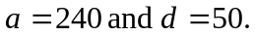
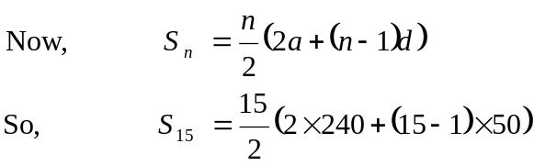
(1 mark)
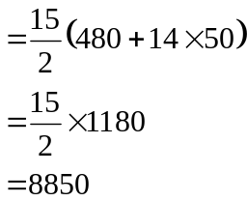
(1 mark)
Question 2
- If  is the number of cases of wine produced for the domestic market in 2001, then 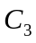 is the number of cases of wine produced for the domestic market in 2003.

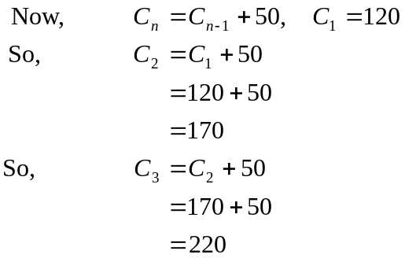
(1 mark)
- According to the difference equation, 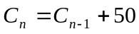, there are 50 cases of wine added each year to the previous year’s production.
So the annual increase is 50 cases. (1 mark)
- The ratio of the number of cases of wine produced for the export market compared to the number of cases of wine produced for the domestic market is 2:1. This means that twice as much wine is produced for the export market as is produced for the domestic market.
This occurs in 2001 since 240 cases are produced for export and 120 are produced for the domestic market. (1 mark)
- We have a total of 1560 cases of wine to be produced. This total is to be divided in the ratio 7:6. This is a total of 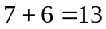parts. Now 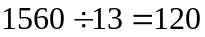. So each part represents 120 cases of wine. (1 mark)
So, 7 parts or 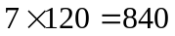cases of wine will go to the export market and 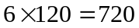cases of wine will go to the domestic market. (1 mark)
(Check your answer;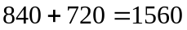which is the total number of cases produced)

Question 3

- 2007 represents the 7th year.
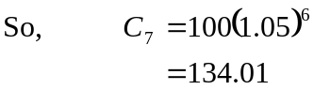
The winery will receive $134.01 per case of wine in 2007.
(1 mark)
- Method 1
Use trial and error.
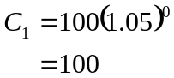
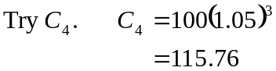
This is too low.
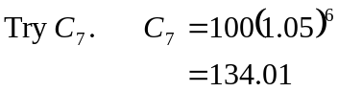
Still too low.
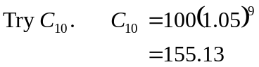
Check that there is not a value just over 150 but less than 155.13.
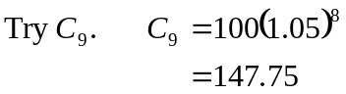
This value is too low.
So, in the 10th year, that is, in 2010, the winery will receive for the first time, more than $150 per case of wine that is exported.
(1 mark)

Method 2
We require n where
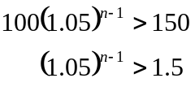
Taking logs of both sides gives us:
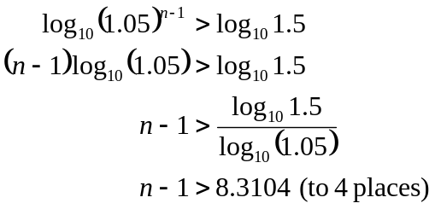
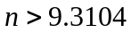
So the next whole number value of is 10. It would be the year 2010 when the winery first receives more than $150 per case of wine that is exported.
(1 mark)

- From Question 1 part b., in 2003 there are to be 340 cases of wine exported.
From Question 3, we know that the amount per case received by the winery in 2003 is given by
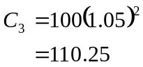
So in 2003 the winery should be paid 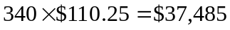.
(1 mark)

- We are looking for the sum of the first 15 terms of the geometric sequence generated by
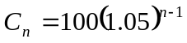
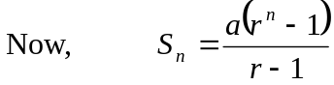 (1 mark)
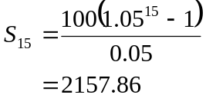
The required sum is $2157.86.
(1 mark)

Total 15 marks
Module 2: Geometry and Trigonometry

Question 1

- We have a right-angled triangle.
So, 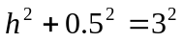 (1 mark)
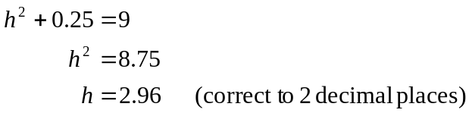
So, 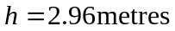 (1 mark)
- We have 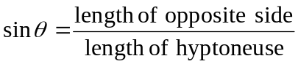
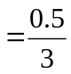 (1 mark)
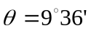 to the nearest minute. (1 mark)

Question 2
- Since AB is parallel to CD, then 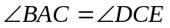 (corresponding angles in parallel lines are equal).
Now, 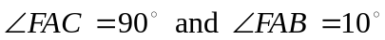
So, 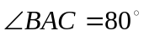
So, 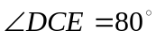
(1 mark)
- In , we have
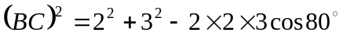 (cosine rule) (1 mark)
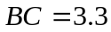 (correct to 1 decimal place)
So 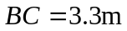 (1 mark)
- In 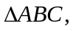 we have
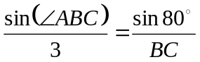 (1 mark)
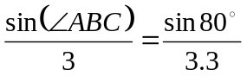 from part b.
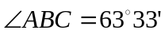 (1 mark)

Question 3

- The scale on the map is 1:400. So we want to find the number x so that 11:x is in the same ratio.
We have multiplied 1 by 11 so we must multiply 400 by 11 to get x. So x = 4400.
So 11cm on the map represents 4400cm or 44m on the actual ground.
(1 mark)

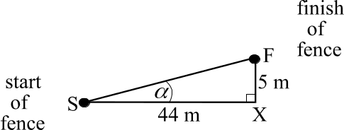
- In the right angled triangle,
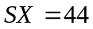(from part a.).

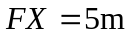
(read from the difference between the contour lines on the contour map).
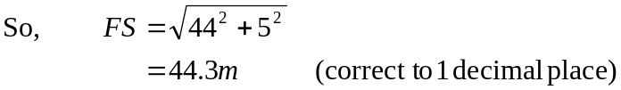
(1 mark)

- From the diagram in part b., we have
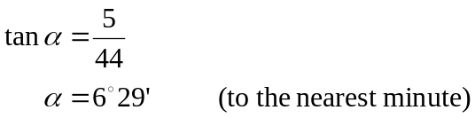
(1 mark)

- The horizontal distance from the start to the finish of the fence is 44m. The 8 panels of the fence are equal in width and so each panel is 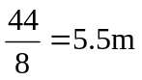wide.
So, the bottom left hand corner of the 6th panel of the fence starts at a horizontal
distance of 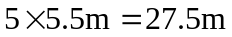 from the bottom left hand corner of the left of the
fence.
(1 mark)

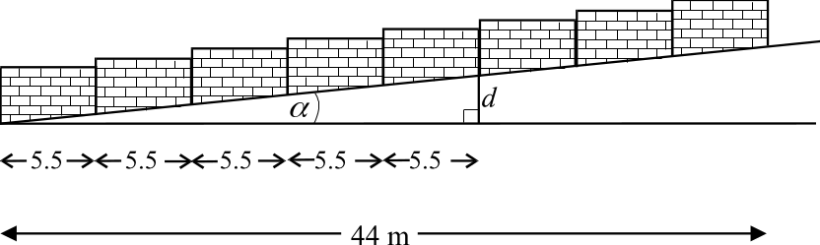

So we have
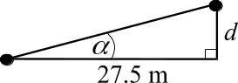

From part c 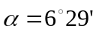
So 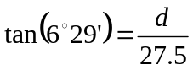 (1 mark)
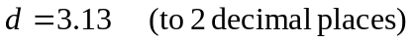
So 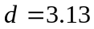metres
(1 mark)
Total 15 marks
Module 3: Graphs and relations

Question 1

- The café opened at 10am. From the graph, when the time was 10am, the amount of water in the tank was 18 litres.
(1 mark)
b. i. The waiter began to add water to the tank when there were 6 litres of water
in the tank.
(1 mark)
ii. At 10.23am there was 6 litres of water in the tank. This amount increases until 10.25am when there was 11 litres in the tank.
So, 5 litres of water were added to the tank.
(1 mark)
iii. At 10.25am no more water was added. Between 10.25am and 10.28am, the amount of water in the tank remained steady at 11 litres. After 10.28am it dropped. So 3 minutes after the water had finished being added, the next coffee was made.
(1 mark)

c. The average rate of change of the amount of water in the tank between 10.05am
and 10.23am is given by
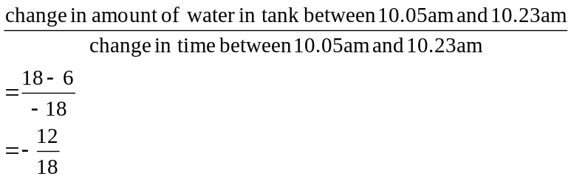
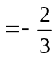litres/minute
(1 mark)
Note that we would expect a negative rate of change since the amount of water has dropped over this period of time.

Question 2

- 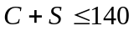 (1 mark)

- 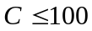 (1 mark)

c. (1 mark) for 3rd constraint which should show a straight line through the points
(140, 0) and (0, 140) with shading below the line.
(1 mark) for 4th constraint which should show a vertical straight line through the
point (100, 0) with shading to the left.
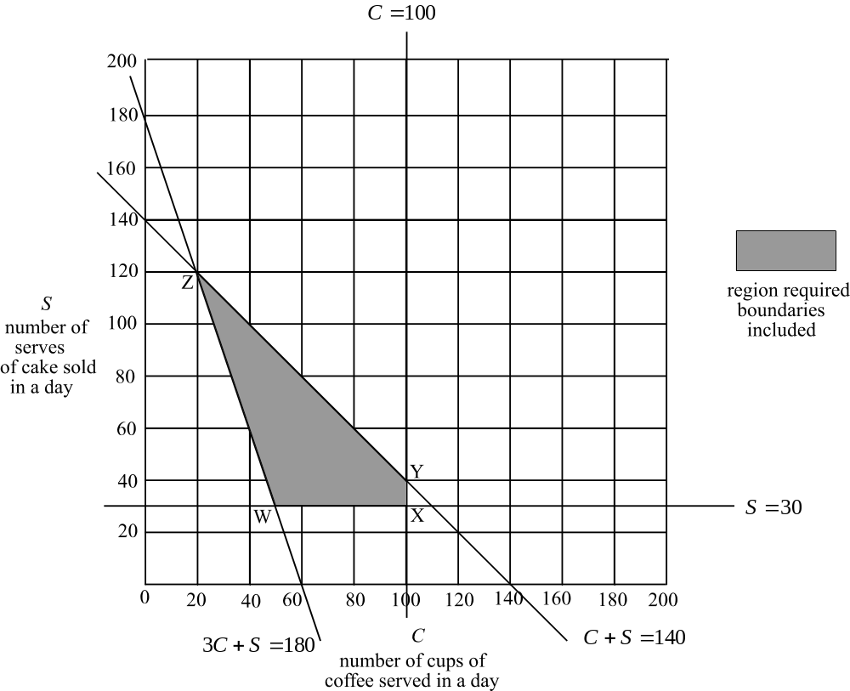

d. (1 mark) for feasible region

Question 3
- 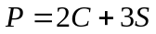 (1 mark)

- Using the feasible region shown on the graph in Question 2 above, firstly find the coordinates of the corner points of the feasible region.
Point W is the point of intersection of the lines with equations
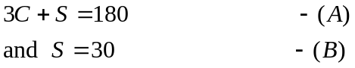
Sub (B) in (A)
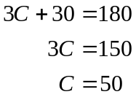
W is the point (50, 30)

Point X is the point of intersection of the lines with equations
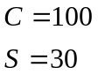
So X is the point (100,30)
Point Y is the point of intersection of the lines with equations
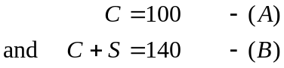
Sub (A) in (B)
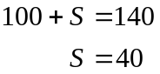
So Y is the point (100, 40)
(2 marks) for finding these 3 points
(1 mark) for finding any one point
Point Z is the point of intersection of the lines with equations
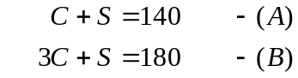
(B) – (A) gives
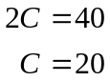
Sub in (A)
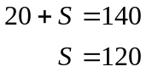
So, Z is the point (20, 120)
(1 mark) for finding point Z
From part a. we have . We want the value of P to be a maximum and we know that this maximum value will occur at one of the corner points of the feasible region; that is, at either point W or X or Y or Z.

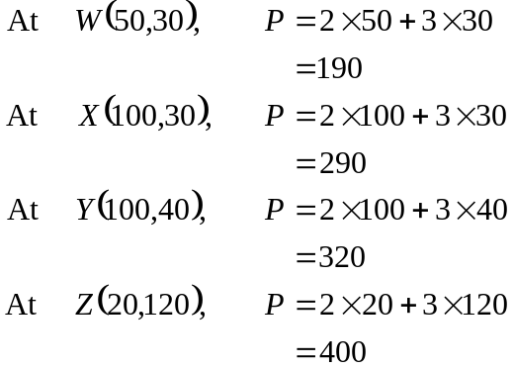
So the maximum profit that can be made in a day from the sale of cups of coffee and serves of cake is $400.
(1 mark)
Total 15 marks

Module 4: Business related mathematics

Question 1
- i. Harold will pay 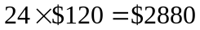
(1 mark)
ii. Interest = $2880 - $2200
= $680 (1 mark)
- Now 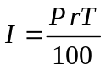 (from the formula sheet)
So, 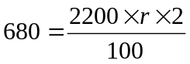 (1 mark)
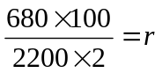
So 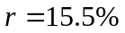
So the flat rate of interest is 15.5% p. a. (1 mark)
- From the formula sheet, we have effective rate of interest
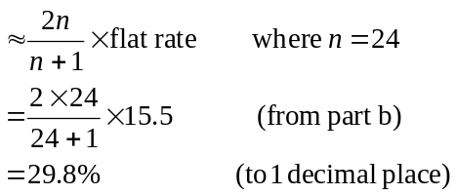
(1 mark)
- Cost of set after 4 years
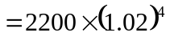
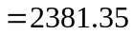 The cost of the set is $2381.35. (1 mark)

Question 2
- 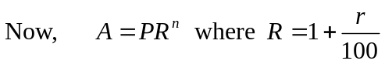 (from the formula sheet)
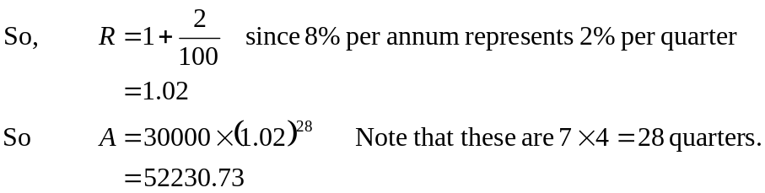
(1 mark)
After 7 years there is $52230.73 in the account. So, Harold has earned in interest. (1 mark)
- (from the formula sheet)
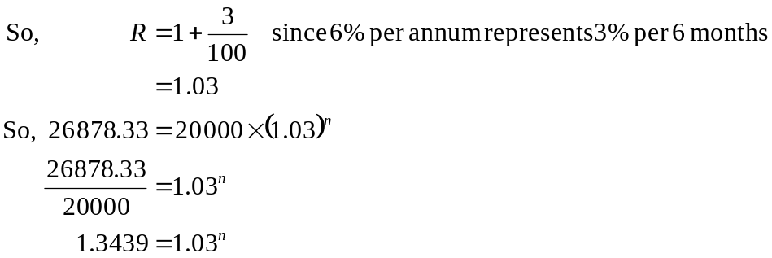
(1 mark)
Method 1 – trial and error
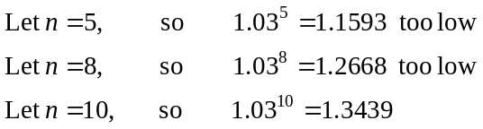
So the number of periods over which the money was invested was 10. Each period was 6 months. So, the money was invested for 5 years.
(1 mark)

Method 2 – using logs
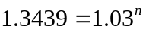
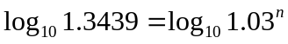
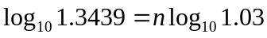
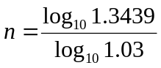
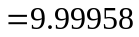
So the number of periods over which the money was invested was 10. Each period was 6 months. So, the money was invested for 5 years.
(1 mark)

Question 3

- i. 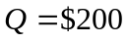
(1 mark)
ii. 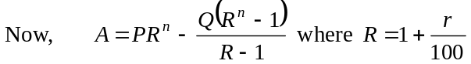
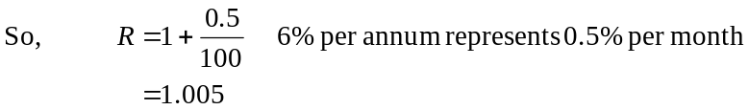
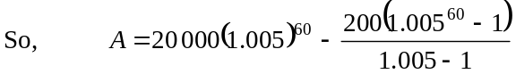 (1 mark)
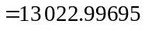
So the amount in the account after 5 years is $13 023.00.
(1 mark)
- After 3 years there is to be $0 in the account.
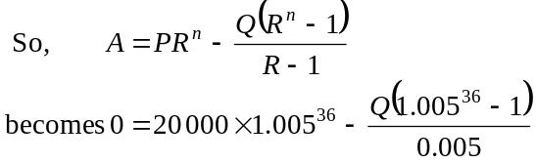
(1 mark)
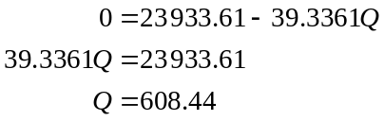
So Norm would receive $608.44 each month.
(1 mark)
Total 15 marks
Module 5: Networks and decision mathematics

Question 1

- A Hamiltonian circuit is a path that goes through each vertex just once before finishing at the starting vertex.
For this network we could have ABFEGDCA or ACDGEFBA.
(1 mark)

- If a driver leaves warehouse A and travels on each of the regular routes just once before returning to Warehouse A then he has completed a Euler circuit. An Euler circuit exists on a network if it is connected (that is, all vertices are connected to at least one other vertex) and the degree of each vertex is even. Clearly on our network, the vertices A, B, C and G have an odd degree. So, a driver cannot complete the required travel.
(1 mark)

- By trial and error, find the shortest distance between warehouse A and warehouse G. For example, the route ABFG is 25 km. The route ACDG is 25km as is ACFG. The route ADG is only 23km. It is the shortest route.
(1 mark)

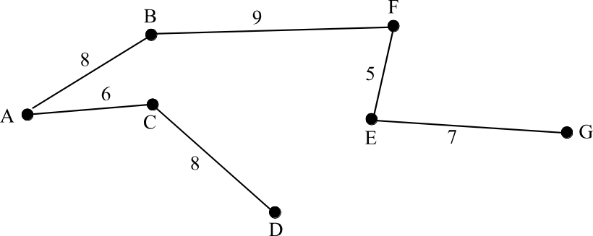

The minimum spanning tree is shown above.
(2 marks)

Question 2

- The immediate predecessors of activity H are activities E and F.
(1 mark)
b.
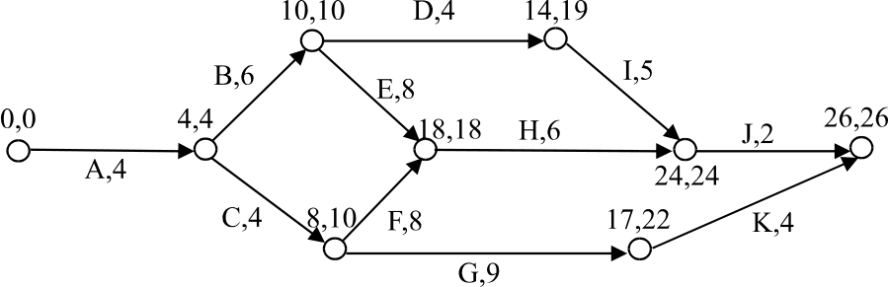

The earliest start time for activity H is 18 weeks.
The latest start time for activity D is 15 weeks.
(2 marks)
c. The critical path is A, B, E, H, J.
(1 mark)

d. It will take 26 weeks to complete the building.
(1 mark)

Question 3
a. Making all the possible reductions involves reducing activity B to 3 weeks,
reducing activity C to 1 week, reducing activity D to 2 weeks and reducing activity E to 7 weeks.
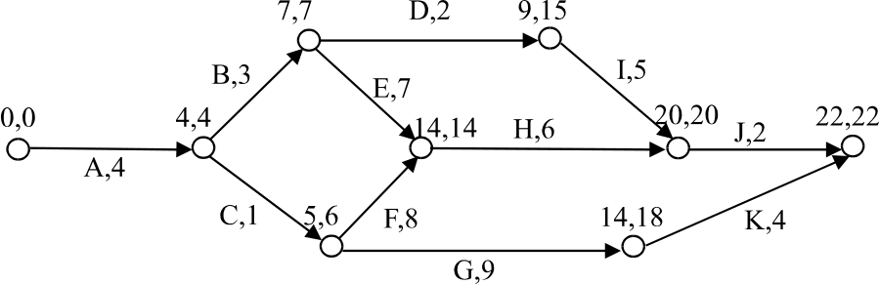

The shortest time that the building will take with all these reductions implemented is 22 weeks.
(2 marks)
b. The network with the original times taken to complete the various activities is shown below. Activity D has an earliest start time of 10 and a latest start time of
19 – 4 = 15.

This gives a slack or float time of 5 weeks. So reducing the time for this activity is useless since it does nothing to reduce the overall time for the building to be completed. Activities B and E were on the original critical path and by reducing them we can reduce the overall completion time for the project. Activity C had originally a latest start time of 10 – 4 = 6 weeks. It therefore had a slack or float time of 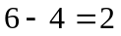 weeks. So, if we reduce activities B and E by a total of 2 weeks, say 1 week each, then activity C comes onto the critical path. To reduce B by 2 more weeks (since E can only be reduced by 1 week) then we must reduce C by 2 weeks. So, in total, we have reduced B by 3 weeks, C by 2 weeks and E by 1 week. Since B and C cannot be reduced any further and since they still lie on the critical path, there is no point reducing C by any more.
The total minimum cost is
(3 marks)
Total 15 marks

